68–95–99.7 rule

Alias

Emprical rule

Intro

68–95–99.7 rule refers the axiom of value lies in interval estimate. In normal distribution , about confidence interval, 1 standard deviation will get about 68.27% probability interval , 2 will get about 95.45, 3 will get about 99.73. And thus, this is the reason why emprical rule is also called 68-95-99.7 rule.

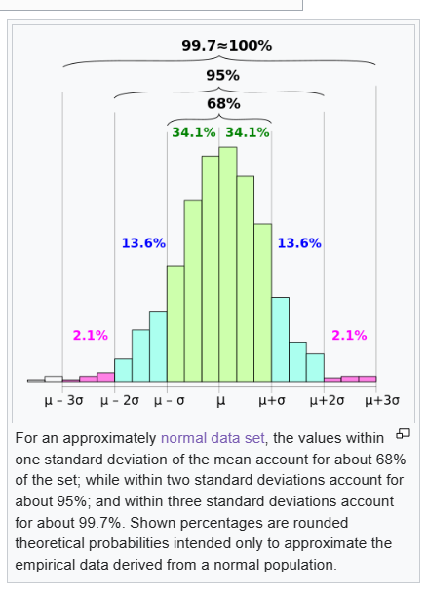

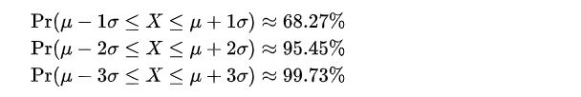

Proof

In normal distribution, we always have that

$$\operatorname{Pr}\left(mu_{x}−n⋅std\left(x\right)≤x≤mu_{x}+n⋅std\left(x\right)\right)$$

=

$$integral\left(\frac{1}{{\left(2⋅pi\left(\right)\right)}^{\frac{1}{2}}⋅std\left(x\right)}⋅e^{−\frac{1}{2}⋅{\left[\frac{\left(x−mu_{x}\right)}{std\left(x\right)}\right]}^{2}}dt ,t=mu_{x}−n⋅std\left(x\right),t=mu_{x}+n⋅std\left(x\right)\right)$$

Do integral substitution with $$u = \frac{\left(x−mu_{x}\right)}{std\left(x\right)}$$.

$$u = \frac{\left(x−mu_{x}\right)}{std\left(x\right)}$$

=> $$du=−\frac{1}{std\left(x\right)}dx$$

The lower bound will be

$$u=−n$$

While the upper bound will be

$$u=n$$

Nextly, we have that

$$\operatorname{Pr}\left(−n≤u≤n\right)$$

= $$integral\left(\frac{1}{{\left(2⋅pi\left(\right)\right)}^{\frac{1}{2}}}⋅e^{−\frac{1}{2}u^{\frac{1}{2}}}dt ,t=−n,t=n\right)$$

Lastly, we put

Ref